Practice for Lesson 2:  
DevOps and Cloud   
Exploring Pipelines and Context of Pipeline Management in OCI

Practices for Lesson 2

Overview

In this Practice, we will Deploying Siebel Application Using Docker Image on Oracle Cloud Infrastructure.

Practice 2-1: Deploying Siebel Application Using Docker Image on Oracle Cloud Infrastructure

Overview

In this practice, you will learn to create Siebel Instance and deploy application using Docker Image.

Tasks

1. Login into the Oracle Cloud Infrastructure.
   1. In a Browser, browse the Oracle Cloud Infrastructure using the provided link (https://console.us-ashburn-1.oraclecloud.com/), enter the **Cloud tenant** and click **Continue**.

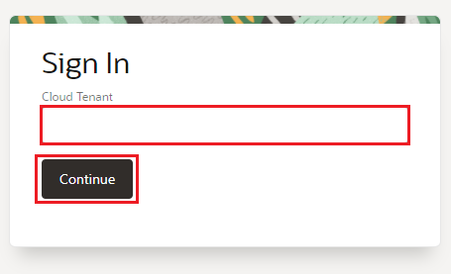

* 1. Enter the given username and password and click **Sign In** to login into the Oracle cloud console.

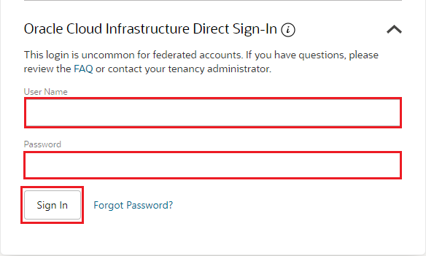

1. Create a VCN with Subnet and Add Ingress rules to the VCN. Adding Ingress rule to the VCN will allow the port to access from the Internet.
   1. In Oracle Cloud Infrastructure, click the navigation menu. Under Core Infrastructure, go to Networking and click Virtual Cloud Networks.

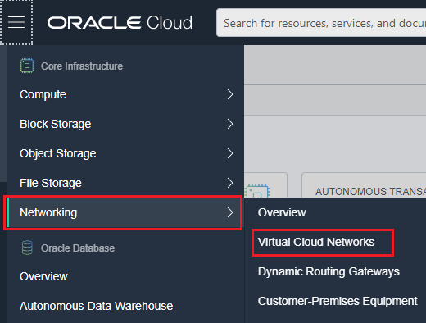

* 1. Select Compartment and click **Create VCN**.

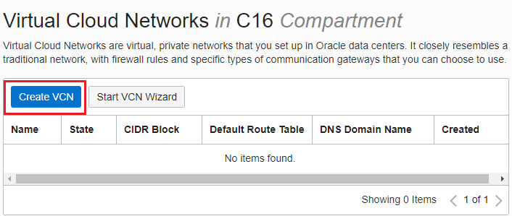

* 1. Enter the **Name** as SiebelIP2020-VCN, select the **Compartment**, enter the CIDR Blocks as **10.0.0.0/24** and click **Create VCN**.

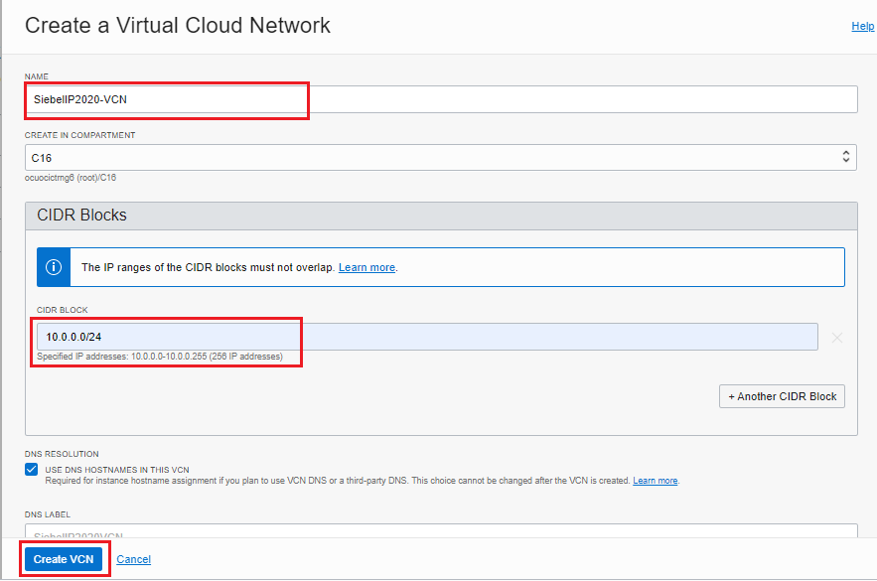

* 1. VCN is created within the Compartment.

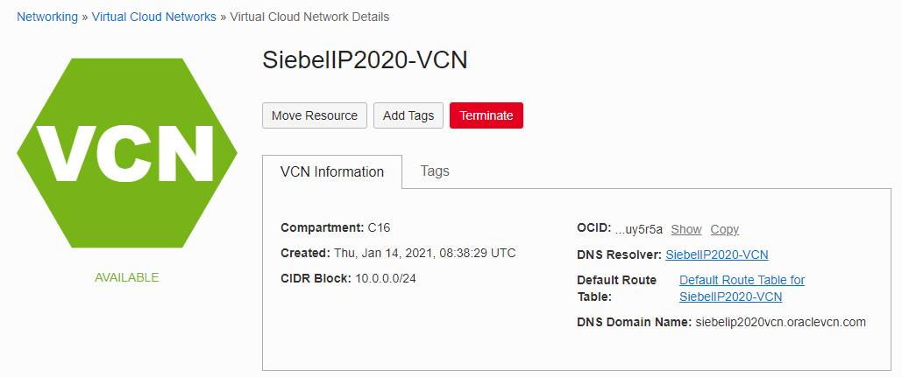

* 1. Now, create Public subnet within the VCN. Click **Create Subnet** to create Subnetin the VCN page.

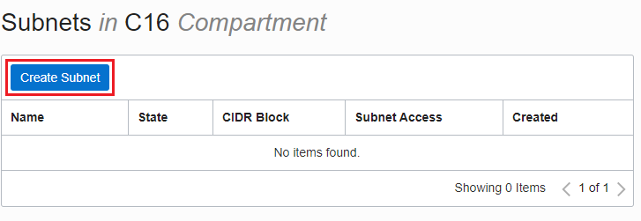

* 1. Enter the Name as **subnet-1**, select **Compartment**, select subnet type as **Regional** and enter the CIDR block as **10.0.0.0/24**  
     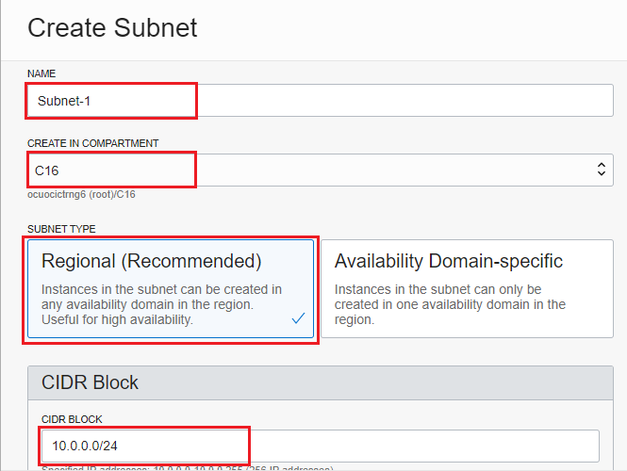
  2. Select the Route Table as **Default** and Subnet Access as **Public Subnet.**

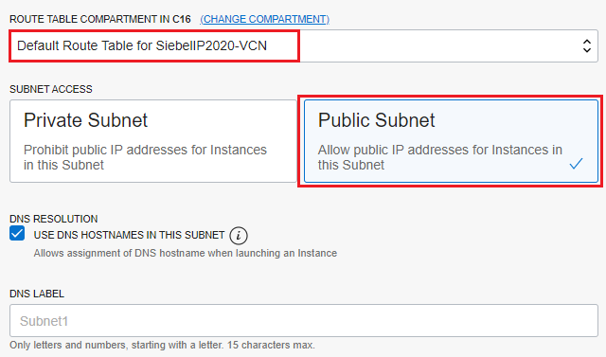

* 1. Select the DHCP as **Default** and Security Table as **Default** and click **Create Subnet** to create subnet.

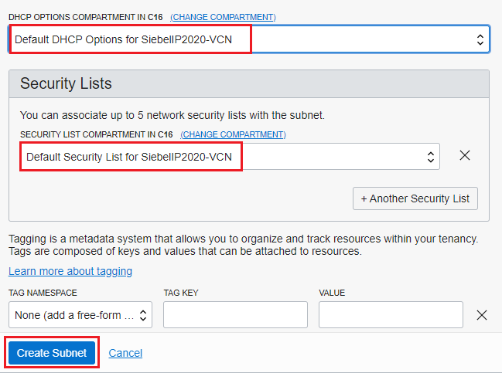

* 1. Now, select **Internet gateway** from Resources and click **Create Internet Gateway**.

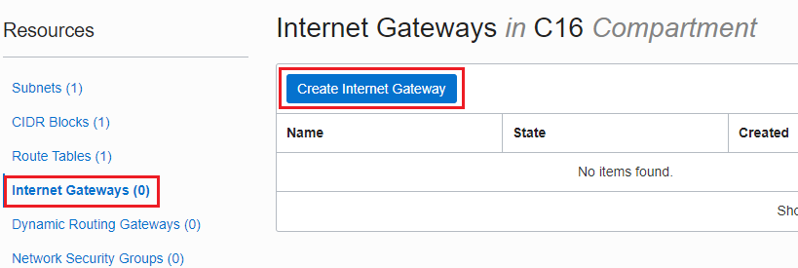

* 1. Enter the name for Internet gateway as **IGW** and click **Create Internet Gateway**.

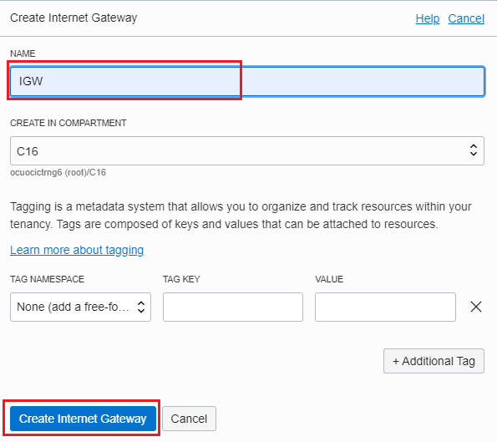

* 1. Select **Route Table** from Resources and click the **Default Route Table**.

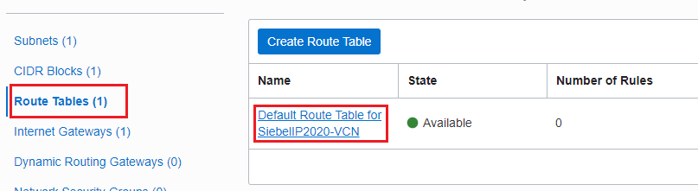

* 1. In Route table page, click **Add Route Rules** to add the Routes.

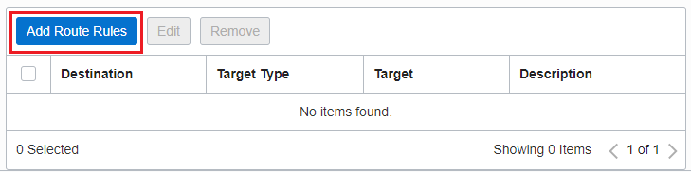

* 1. In Add Route Rules dialog box, select target type as **Internet Gateway**, Destination CIDR Block as **0.0.0.0/0** and Select the Internet Gateway as **IGW** created in previous step. Click **Add Route Rules**.

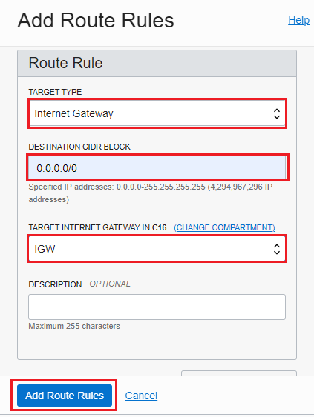

* 1. Navigate back to VCN, select Security Lists from Resources and Select the **Default Security List**.

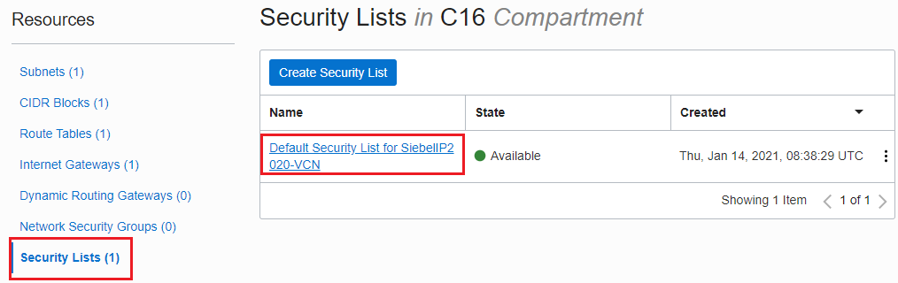

* 1. Click **Add Ingress Rule** in Security List page, allow incoming traffic on selected ports.

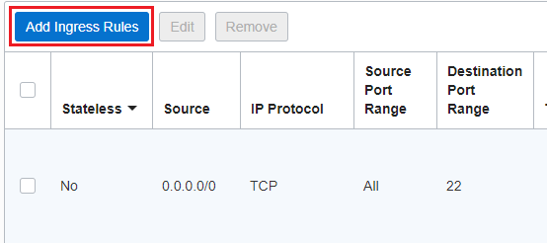

* 1. In Add Ingres dialog box, enter the source CIDR as 0.0.0.0/0 and Destination Port Range as 4430. Then Click **+Add Ingress Rule** to add another Rule.

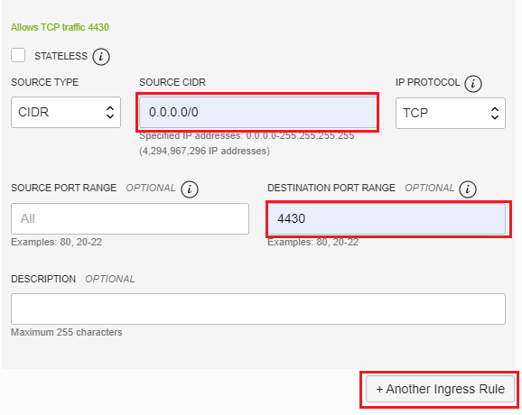

* 1. Enter the source CIDR as 0.0.0.0/0 and Destination Port Range as 8443. Then click **Add Ingress** to add ingress rules to the VCN.

1. Create the Siebel Instance from oracle Market Place.
   1. Navigate to Oracle Cloud Infrastructure **Marketplace** and Click **Application**.

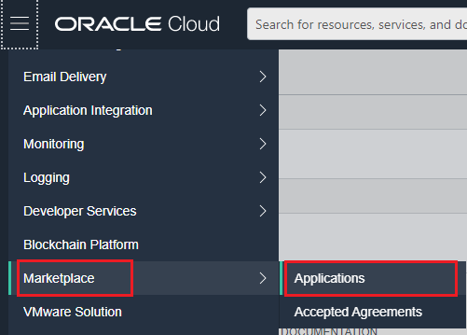

* 1. Search for **Siebel** and select **Siebel CRM 20.x Install Container with sample database**.

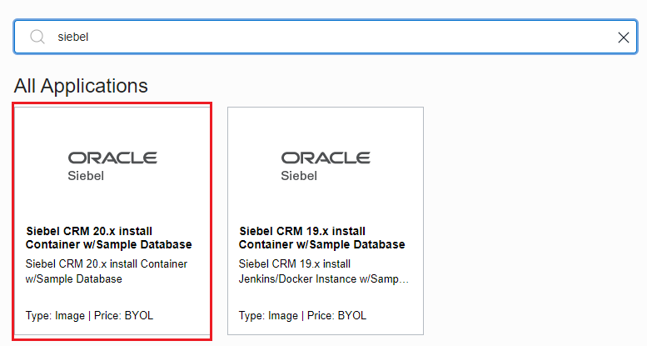

* 1. In Siebel Application Page, check the box to accept the Terms and click **Launch Instance**.

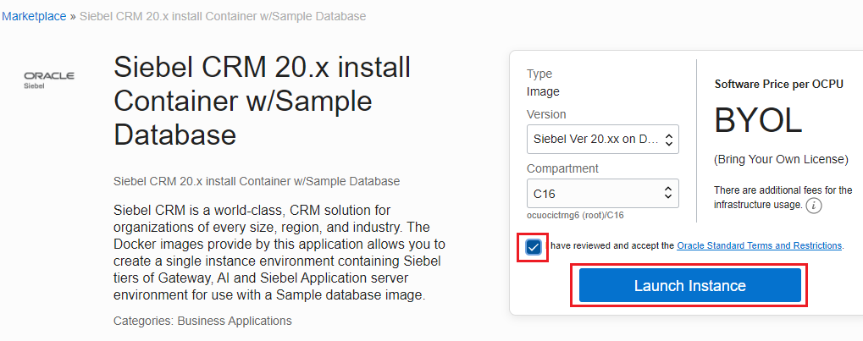

* 1. In Create Compute Instance page, enter name as **Siebel_instance** and Availability domain as **AD-1**

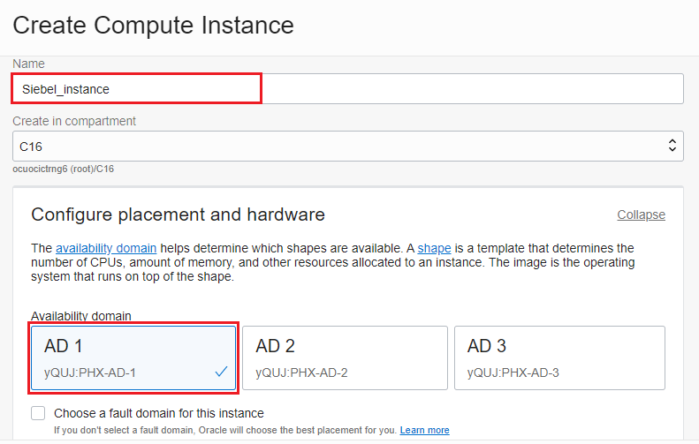

* 1. Click **Change Shape** to change the shape of the Instance.

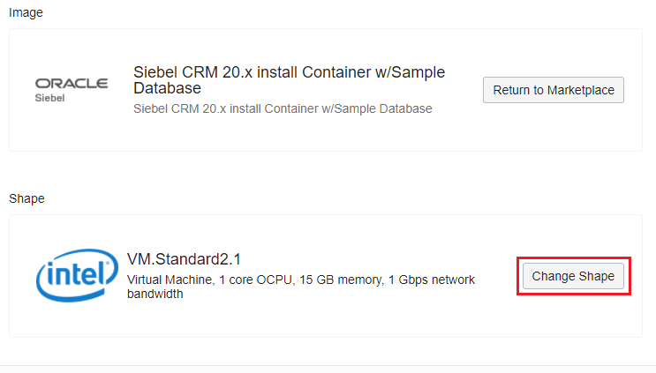

* 1. In configure networking, select the VCN **SiebelIP2020-VCN**, Subnet as **Subnet-1**, and select **Assign Public IP Address**.

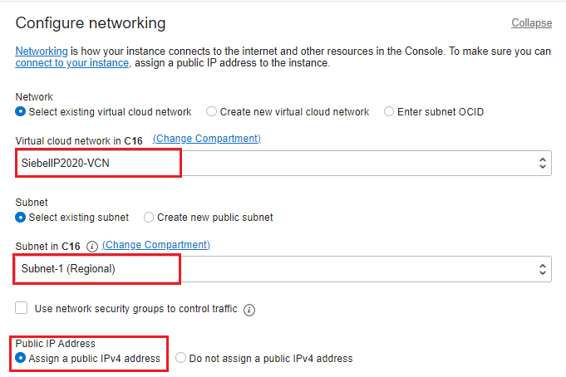

* 1. In Add SSH keys, select **Generate SSHKeys (default option)**  and save the File path downloaded as Public keys and Private keys in a local folder in your desktop.

Click **create** to create the instance.

* 1. Siebel instance is created and running as displayed.

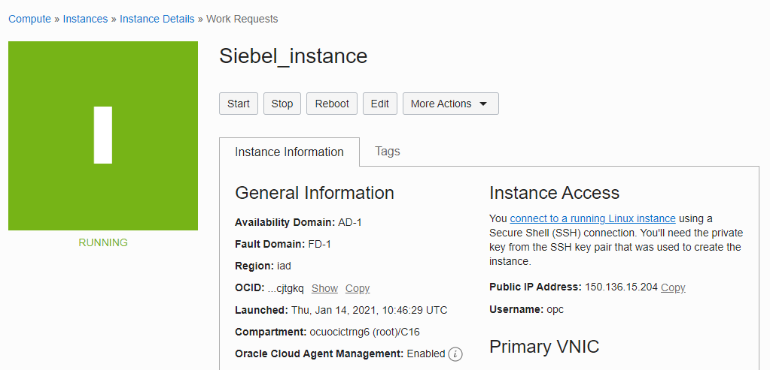

* 1. Now, copy the **Public IP Address** of the Instance.

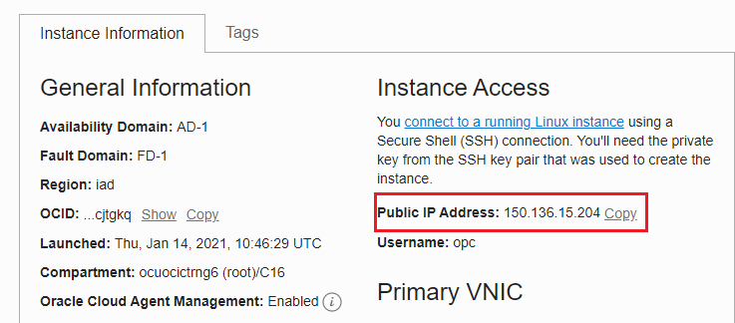

* 1. Paste the Public IP address of the Instance with Port 8080 (https://<IP-address>:8443) to open the Jenkins.
  2. Enter the username as **siebel** and password as **oracle** and click **Sign in** to login into the Jenkins.

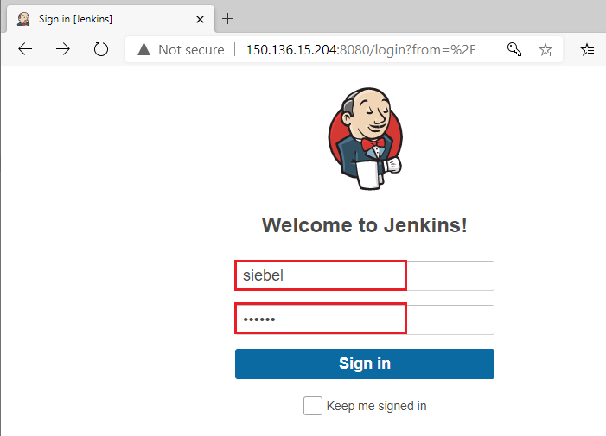

* 1. You have successfully logged in to the Jenkins.

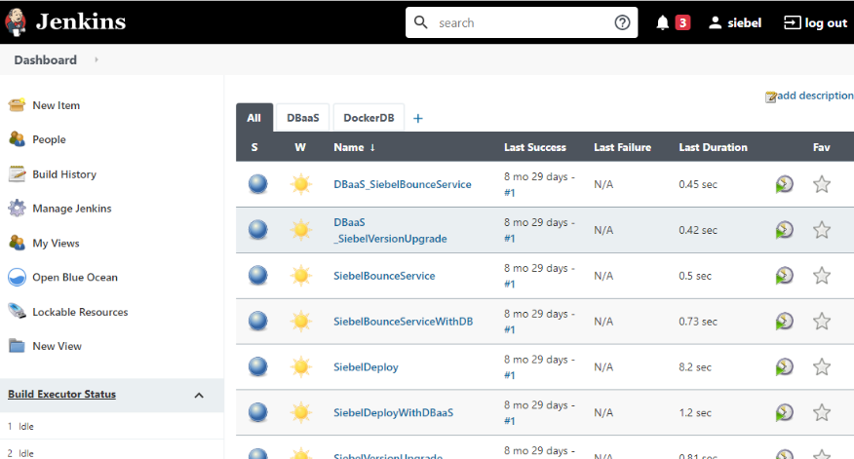

1. Deploy Siebel application using the Jenkins as Docker container.
   1. In Jenkins Dashboard, click **SiebleDeploy** pipeline

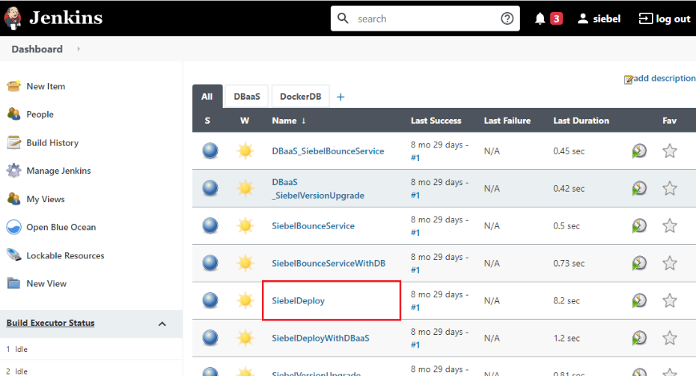

* 1. Click **Open Blue Ocean** from left navigation bar in the Pipeline SiebelDeploy page.

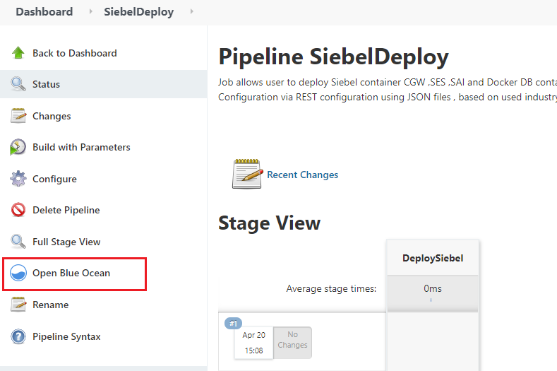

* 1. In the deployment screen, click **Run** to deploy the application.

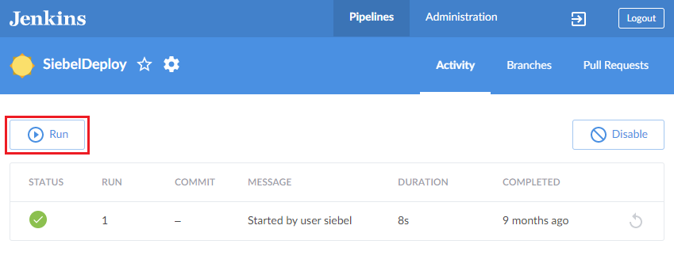

* 1. In the Input required dialog box, Select the **Siebel Version**, Siebel Industry as **Sales** and choose Siebel Docker DB to be deployed as **Sample**. Click **Run** to deploy the application.

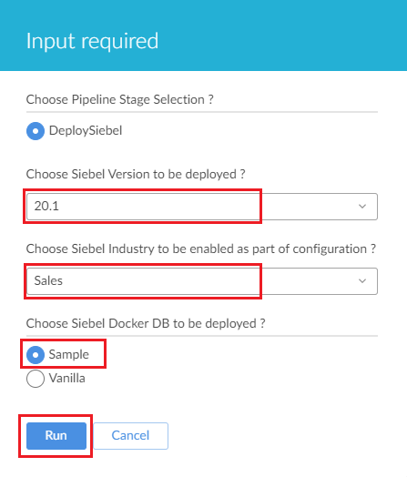

* 1. The application deployment process has started.

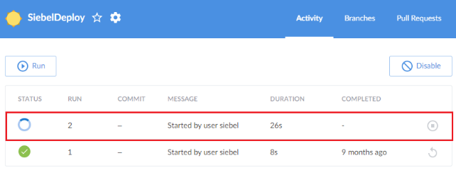

* 1. Click on deployment to view the details of the deployment.

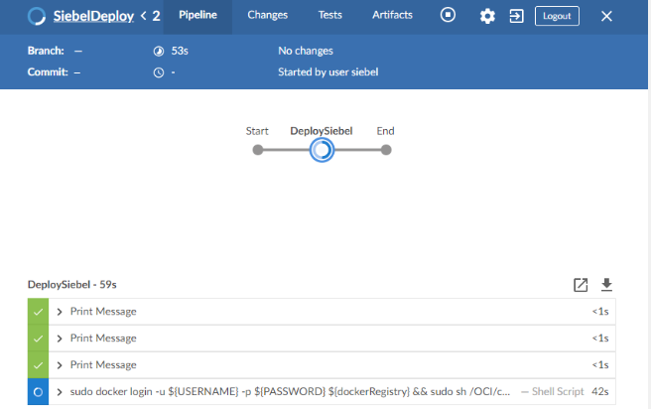

* 1. Application is deployed successfully as displayed.

